On the master node – IF U LOST JOIN COMMAND

kubeadm token create --print-join-command

Below all steps on minion node

yum install docker -y && systemctl enable docker && systemctl start docker

cat <<EOF > /etc/yum.repos.d/kubernetes.repo

[kubernetes]

name=Kubernetes

baseurl=https://packages.cloud.google.com/yum/repos/kubernetes-el7-x86_64

enabled=1

gpgcheck=1

repo_gpgcheck=1

gpgkey=https://packages.cloud.google.com/yum/doc/yum-key.gpg https://packages.cloud.google.com/yum/doc/rpm-package-key.gpg

EOF

cat /etc/yum.repos.d/kubernetes.repo

setenforce 0

yum install -y kubelet kubeadm

sudo systemctl enable kubelet && systemctl start kubelet

Next step

kubeadm join --token ba0689.104b8534bac9ff71 10.128.0.5:6443 --discovery-token-ca-cert-hash sha256:7d56e6ca5462e5613a95db86165799cd6f971c3a8e5cf4d4e2db8fdb51a3f48c --skip-preflight-checks

docker ps

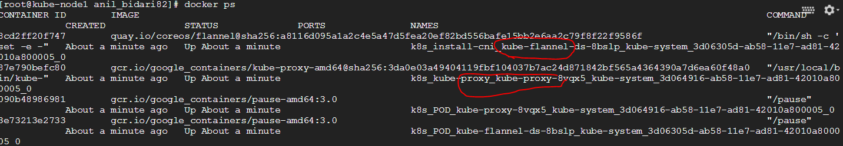

Goto your **master node**

Kubectl get nodes

